Δυναμικές Ιστοσελίδες (jsp pages, mySQL)

Θέμα
Εργάζεστε για την εταιρεία Mythical Car, μια εταιρεία πώλησης αυτοκινήτων, και σας ανατίθεται ο σχεδιασμός της Βάσης Δεδομένων των πωλήσεων της εταιρείας.
Περιορισμοί
- Η εταιρία Mythical Car εμπορεύεται πολλές μάρκες αυτοκινήτων (Βrandnames): Audi, Opel,....
- Κάθε πωλητής (salesman) της εταιρείας πουλά αυτοκίνητα για περισσότερες από μία μάρκες.
- Για κάθε μάρκα υπάρχει καταχωρημένος ο αριθμός πωλήσεων (no_of_sales).

Ασκήσεις
- Για την παραπάνω περιγραφή δημιουργείστε τους κατάλληλους πίνακες .
- Κατασκευάστε τη διεπαφή μέσω της οποίας ο πωλητής θα καταχωρεί την πώληση ενός αυτοκινήτου (jsp σελίδες).
- Δημιουργείστε τον κατάλληλο trigger ο οποίος θα ενεργοποιείται με κάθε νέα πώληση προκειμένου να αυξήσει τον αριθμό των πωλήσεων (no_of_sales).
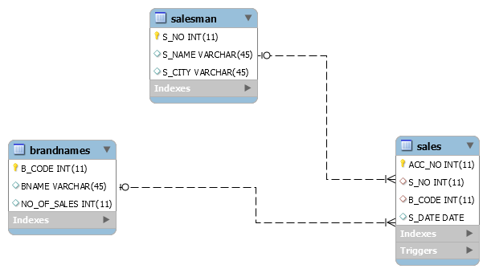
DESCRIBE SALES;
DESCRIBE BRANDNAMES;
DESCRIBE SALESMAN;
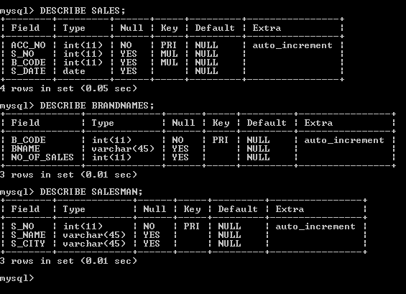

SELECT * FROM sales;
SELECT * FROM brandnames;
SELECT * FROM salesman;

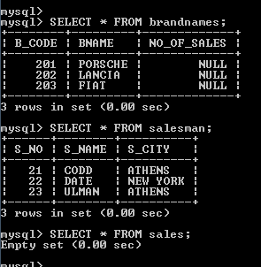

DROP DATABASE mythical_car;
CREATE DATABASE mythical_car;
USE mythical_car;

-- -----------------------------------------------------
-- Table `mythical_car`.`brandnames`
-- -----------------------------------------------------
CREATE TABLE brandnames (
B_CODE INT(11) NOT NULL AUTO_INCREMENT,
BNAME VARCHAR(45) NULL DEFAULT NULL,
NO_OF_SALES INT(11) NULL DEFAULT NULL,
PRIMARY KEY (B_CODE))
ENGINE = InnoDB
AUTO_INCREMENT = 201
DEFAULT CHARACTER SET = utf8;

-- -----------------------------------------------------
-- Table `mythical_car`.`salesman`
-- -----------------------------------------------------
CREATE TABLE salesman (
S_NO INT(11) NOT NULL AUTO_INCREMENT,
S_NAME VARCHAR(45) NULL DEFAULT NULL,
S_CITY VARCHAR(45) NULL DEFAULT NULL,
PRIMARY KEY (S_NO))
ENGINE = InnoDB
AUTO_INCREMENT = 21
DEFAULT CHARACTER SET = utf8;

-- -----------------------------------------------------
-- Table `mythical_car`.`sales`
-- -----------------------------------------------------
CREATE TABLE sales (
ACC_NO INT(11) NOT NULL AUTO_INCREMENT,
S_NO INT(11) NULL DEFAULT NULL,
B_CODE INT(11) NULL DEFAULT NULL,
S_DATE DATE NULL DEFAULT NULL,
PRIMARY KEY (ACC_NO),
INDEX S_NO (S_NO ASC),
INDEX B_CODE (B_CODE ASC),
CONSTRAINT `sales_ibfk_1`
FOREIGN KEY (S_NO)
REFERENCES salesman (S_NO),
CONSTRAINT sales_ibfk_2
FOREIGN KEY (B_CODE)
REFERENCES brandnames (B_CODE))
ENGINE = InnoDB
AUTO_INCREMENT = 1
DEFAULT CHARACTER SET = utf8;

DELIMITER $$

USE `mythical_car`$$
DROP TRIGGER IF EXISTS `mythical_car`.`TOTAL_SALES` $$
USE `mythical_car`$$
CREATE
DEFINER=`root`@`localhost`
TRIGGER `mythical_car`.`TOTAL_SALES`
BEFORE INSERT ON `mythical_car`.`sales`
FOR EACH ROW
UPDATE BRANDNAMES SET NO_OF_SALES=IFNULL(NO_OF_SALES,0)+1
WHERE BRANDNAMES.B_CODE=NEW.B_CODE$$

DELIMITER ;

INSERT INTO brandnames(BNAME) VALUES ('PORSCHE');
INSERT INTO brandnames(BNAME) VALUES ('LANCIA');
INSERT INTO brandnames(BNAME) VALUES ('FIAT');
INSERT INTO salesman(S_NAME, S_CITY)VALUES('CODD','ATHENS');
INSERT INTO salesman(S_NAME,S_CITY) VALUES('DATE','NEW YORK');
INSERT INTO salesman(S_NAME,S_CITY) VALUES('ULMAN','ATHENS');

SELECT * FROM brandnames;
SELECT * FROM salesman;
SELECT * FROM sales;
Mythical Car JSP pages
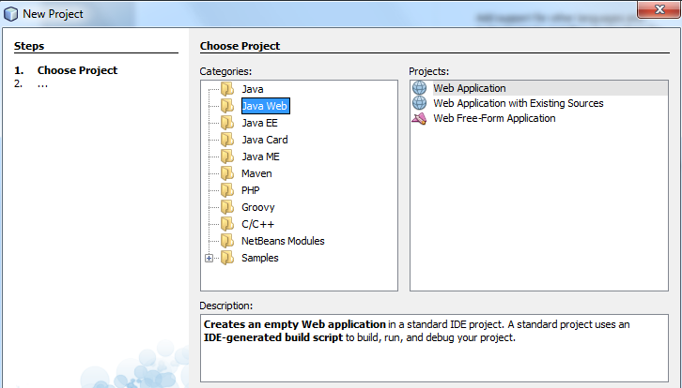

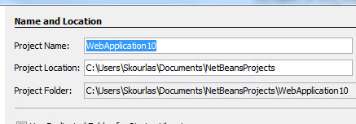

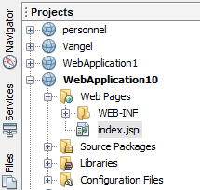
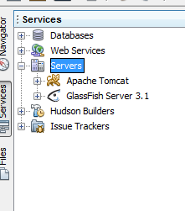

menu.jsp
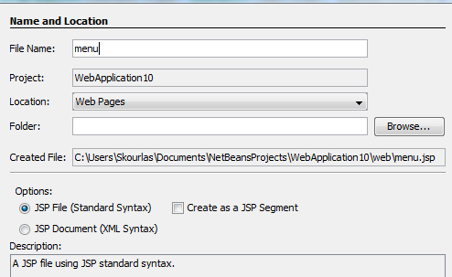

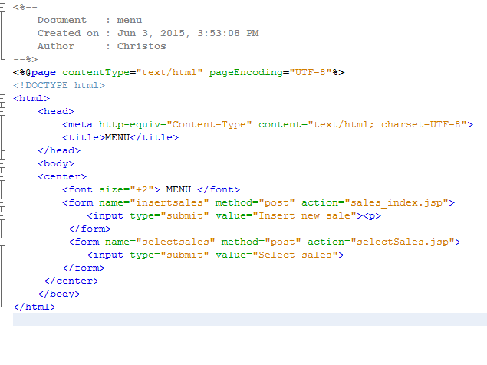
<%--
Document : menu
Created on : Jun 3, 2015, 3:53:08 PM
Author : Christos
--%>
<%@page contentType="text/html" pageEncoding="UTF-8"%>
<!DOCTYPE html>
<html>
<head>
<meta http-equiv="Content-Type" content="text/html; charset=UTF-8">
<title>MENU</title>
</head>
<body>
<center>
<font size="+2"> MENU </font>
<form name="insertsales" method="post" action="sales_index.jsp">
<input type="submit" value="Insert new sale"><p>
</form>
<form name="selectsales" method="post" action="selectSales.jsp">
<input type="submit" value="Select sales">
</form>
</center>
</body>
</html>

sales_index.jsp
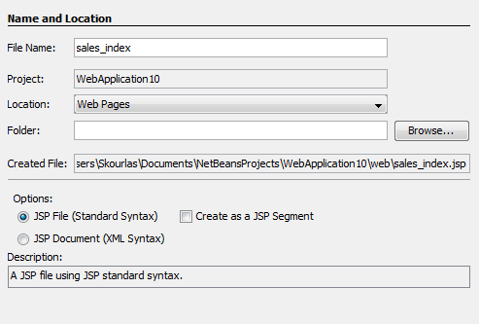

<%--
Document : sales_index
Created on : Jun 3, 2015, 3:16:03 PM
Author : Christos
--%>
<%@page contentType="text/html" pageEncoding="UTF-8"%>
<!DOCTYPE html>
<html>
<head>
<meta http-equiv="Content-Type" content="text/html; charset=UTF-8">
<title>Insert new sale</title>
</head>
<body>
<center>
Fill the text boxes below
<form name="salesIndex" method="post" action="salesInsert.jsp">
Salesman no: <input type="text" name="s_no" > <p>
Brand code: <input type="text" name="b_code" > <p>
Sale date : <input type="text" name="s_date" ><p>
<input type="submit" value="Insert new sale" >
</form>
</center>
</body>
</html>
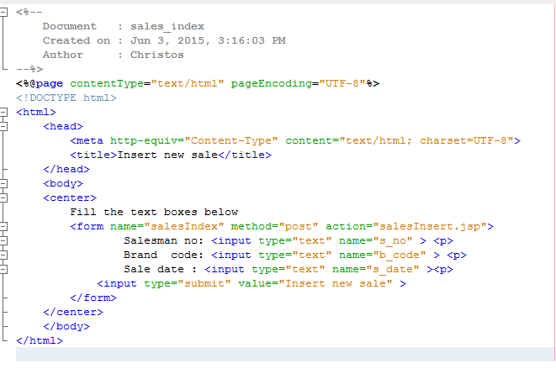

salesInsert.jsp
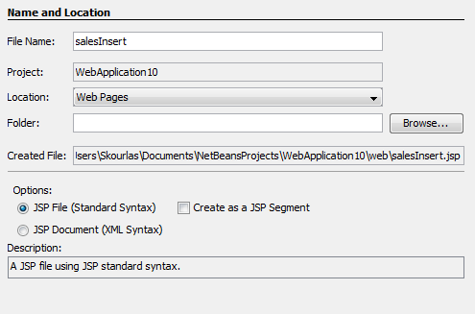

<%--
Document : salesInsert
Created on : Jun 3, 2015, 3:20:28 PM
Author : Christos
--%>
<%@page contentType="text/html" pageEncoding="UTF-8"%>
<%@page import="java.sql.*" %>
<%
int s_no=Integer.parseInt(request.getParameter("s_no"));
int b_code=Integer.parseInt(request.getParameter("b_code"));
String s_date=request.getParameter("s_date");
%>
<!DOCTYPE html>
<html>
<head>
<meta http-equiv="Content-Type" content="text/html; charset=UTF-8">
<title>JSP Page</title>
</head>
<body>
<%
Class.forName("com.mysql.jdbc.Driver");
// Define the connection parameters
String myDatabase = "jdbc:mysql://localhost:3306/MYTHICAL_CAR?user=root&password=1234";
// Connect to the database
Connection myConnection = DriverManager.getConnection(myDatabase);
// Create object to execute statements
Statement myStatement = myConnection.createStatement();
String SQLstring="INSERT INTO SALES (S_NO,B_CODE,S_DATE) VALUES ('"+s_no+"','"+b_code+"','"+s_date+"') ";

myStatement.executeUpdate(SQLstring);
myStatement.close();
myConnection.close();
%>
<form name="goBack" method="post" action="menu.jsp">
<script>
document.forms["goBack"].submit();
</script>
</form>
</body>
</html>
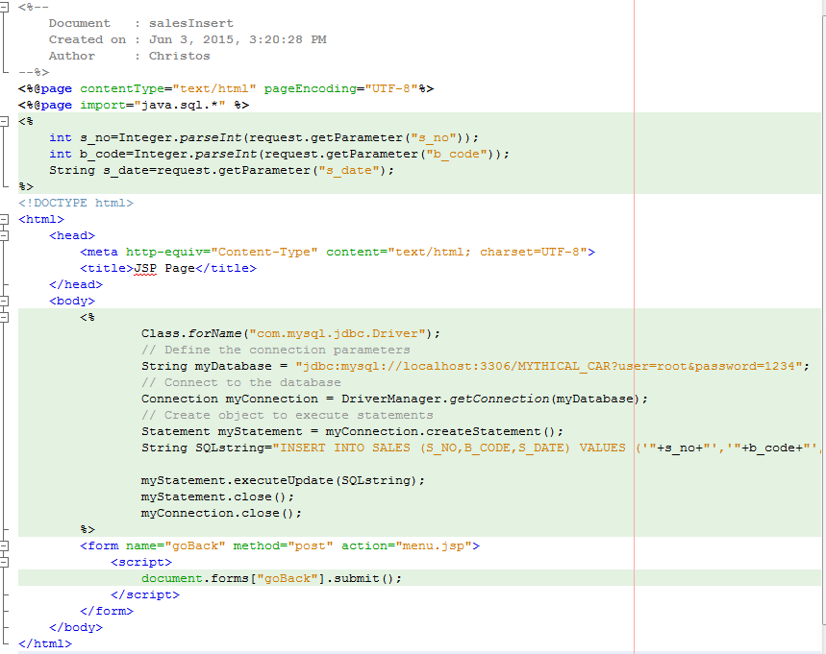
selectSales.jsp
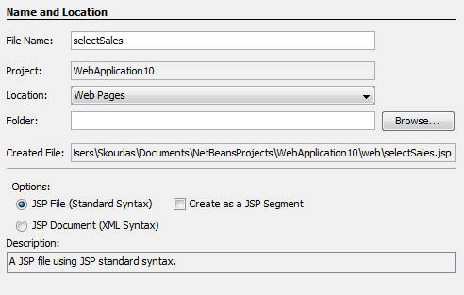

<%--
Document : selectSales
Created on : Jun 3, 2015, 3:52:48 PM
Author : Christos
--%>
<%@page contentType="text/html" pageEncoding="UTF-8"%>
<%@page import="java.sql.*" %>
<!DOCTYPE html>
<html>
<head>
<meta http-equiv="Content-Type" content="text/html; charset=UTF-8">
<title>Sales</title>
</head>
<body>
<%
Class.forName("com.mysql.jdbc.Driver");
// Define the connection parameters
String myDatabase = "jdbc:mysql://localhost:3306/MYTHICAL_CAR?user=root&password=1234";
// Connect to the database
Connection myConnection = DriverManager.getConnection(myDatabase);
// Create object to execute statements
Statement myStatement = myConnection.createStatement();
String SQLstring="SELECT * FROM SALES; ";
ResultSet rs=myStatement.executeQuery(SQLstring);
int [] acc_no=new int[200];
int [] s_no=new int[200];
int [] b_no=new int[200];
String [] s_date= new String[200];
int j=0;
while(rs.next())
{
acc_no[j]=rs.getInt("ACC_NO");
s_no[j]=rs.getInt("S_NO");
b_no[j]=rs.getInt("B_CODE");
s_date[j]=rs.getString("S_DATE");
j++;
}
for(int i=0; i<j; i++)
{

%>

Sales_no:<%= acc_no[i]%> <p>
Salesman_no: <%= s_no[i]%> <p>
Brand code: <%= b_no[i]%> <p>
Sales date: <%= s_date[i]%> <p>
<p><p><p>

<%
}
myStatement.close();
myConnection.close();
%>

<form name="goBack" method="post" action="menu.jsp">
<input type="submit" value="GO BACK TO MENU" >
</form>
</body>
</html>
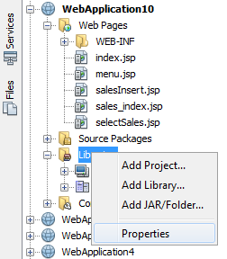
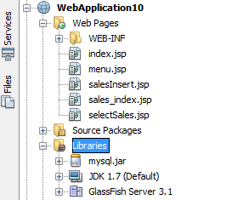

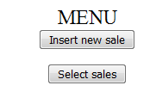

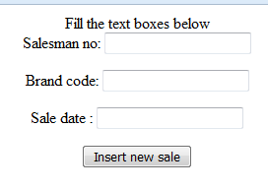

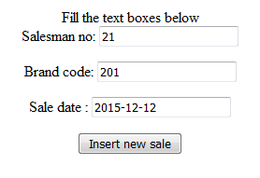
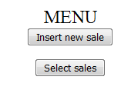
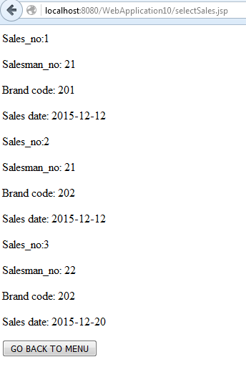
SELECT * FROM brandnames;
SELECT * FROM salesman;
SELECT * FROM sales;
