**SECI model of knowledge dimensions**

<https://en.wikipedia.org/wiki/SECI_model_of_knowledge_dimensions>

Four modes of knowledge conversion were identified (Figure 1):

1. **Tacit to Tacit (Socialization)** - This dimension explains Social interaction as tacit to tacit knowledge transfer, sharing tacit knowledge face-to-face or through experiences. For example, meetings and brainstorm can support this kind of interaction. Since tacit knowledge is difficult to formalize and often time and space specific, tacit knowledge can be acquired only through shared experience, such as spending time together or living in the same environment. Socialization typically occurs in a traditional apprenticeship, where apprentices learn the tacit knowledge needed in their craft through hands-on experience, rather than from written manuals or textbooks
2. **Tacit to Explicit (Externalization)** - Between tacit and explicit knowledge by Externalization (publishing, articulating knowledge), developing factors, which embed the combined tacit knowledge which enable its communication. For example, concepts, images, and written documents can support this kind of interaction. When tacit knowledge is made explicit, knowledge is crystallized, thus allowing it to be shared by others, and it becomes the basis of new knowledge. Concept creation in new product development is an example of this conversion process
3. **Explicit to Explicit (Combination)** - Explicit to explicit by Combination (organizing, integrating knowledge), combining different types of explicit knowledge, for example building prototypes. The creative use of computerized communication networks and large-scale databases can support this mode of knowledge conversion. Explicit knowledge is collected from inside or outside the organisation and then combined, edited or processed to form new knowledge. The new explicit knowledge is then disseminated among the members of the organization
4. **Explicit to Tacit (Internalization)** - Explicit to tacit by Internalization (knowledge receiving and application by an individual), enclosed by learning by doing; on the other hand, explicit knowledge becomes part of an individual's knowledge and will be assets for an organization. Internalization is also a process of continuous individual and collective reflection and the ability to see connections and recognize patterns and the capacity to make sense between fields, ideas, and concepts.

After [Internalization](https://en.wikipedia.org/wiki/Internalization) the process continues at a new ‘level’, hence the metaphor of a “spiral” of knowledge creation (Nonaka & Takeuchi 1995: 71-2, 89) often referred to as the SECI model.

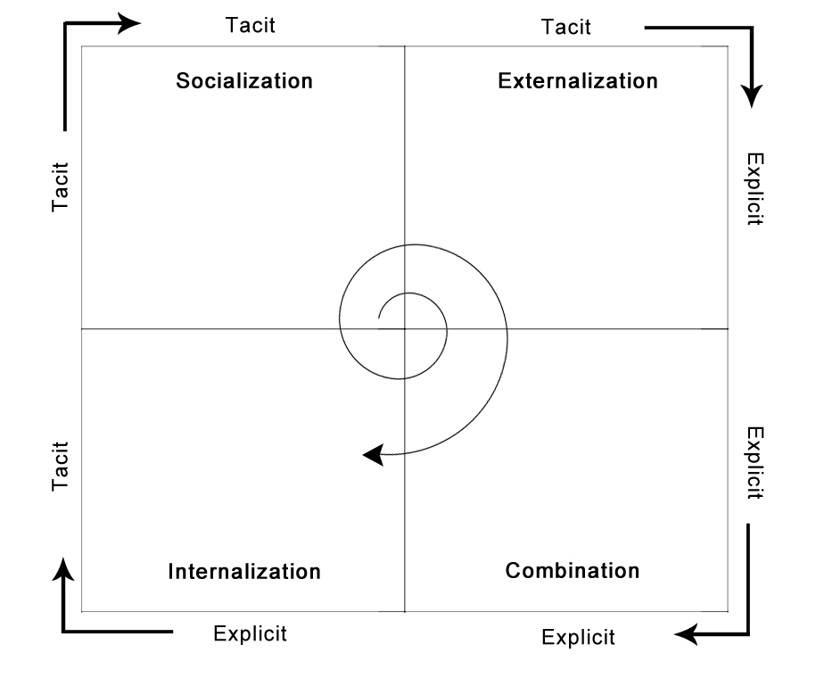

## Advantages of the SECI model

1. Appreciates the dynamic nature of knowledge and knowledge creation.
2. Provides a framework for management of the relevant processes.

## Disadvantages of the SECI model

1. It is based on a study of Japanese organizations, which heavily rely on tacit knowledge: employees are often with a company for life.
2. The linearity of the concept: can the spiral jump steps? Can it go counter-clockwise?

# SECI Model of Knowledge Dimensions (Ikujiro Nonaka)

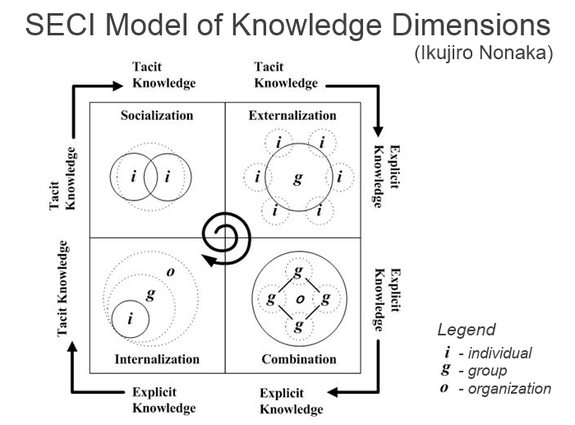

This model visualizes the way of knowledge creation in the knowledge-intensive organizations with epistemology and social-interaction in mind. There are four phases in the knowledge development are defined:

1. **Tacit » Tacit (Socialization)** - tacit knowledge can not be formalized or easily extracted into manuals, so people obtain it through shared experience with mentors who possess such knowledge.
2. **Tacit » Explicit (Externalization)** - the knowledge is extracted into the explicit shape of documents, frameworks, visualizations or instructions, thus it becomes possible to be shared and transferred.
3. **Explicit » Explicit (Combination)** - the knowledge further evolves in combinations of explicit knowledge, business processes are automated, new products or prototypes are built.
4. **Explicit » Tacit (Internalization)** - explicit knowledge is then internalized by the staff who learns by doing and applying it in their daily work and decision making.

<http://www.comindwork.com/weekly/2015-04-27/productivity/SECI-model-of-knowledge-dimensions-Ikujiro-Nonaka>

## **Topic: Knowledge Transfer (SECI Model)**

https://samirshira.wordpress.com/2013/08/30/topic-knowledge-transfer-seci-model/

During a tutorial class a couple of weeks ago, we presented the SECI Model and explained how knowledge is transferred into an organization and/or in our daily life activities, most especially games that we play and have fun with.

Link to the game i introduced to my course mates: <http://www.youtube.com/watch?v=VKKwgJlpYKg>

The purpose of this to understand the dynamic nature of knowledge creation, and to manage such a process effectively. More so, explicit and tacit knowledge interact with each other in a continuous process.

**SECI MODEL**

* **Socialization:**face to face communication or shared experience.
* **Externalization:**convert tacit to explicit knowledge by developing concepts and models.
* **Combination:**Gathering externalized explicit knowledge to broader entities and concept systems
* **Internalization:**understanding explicit knowledge. It happens when explicit knowledge transforms to tacit and becomes a part of individual’s basic information.

[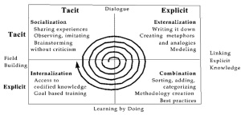](https://samirshira.files.wordpress.com/2013/08/nonaka.jpg)

**CLASS ACTIVITY – Chafe**

We and the lecturer decided to do a game activity which incorporates the SECI Model. Students may apply the concept and purpose through the activity. Firstly the lecturer decided to do “batu seremban” but since we are short of materials, she asked each one of us to come up with 1 traditional game, and luckily we found “Chafe” which reminds me of my childhood days.